GITHUB LINK: https://github.com/loci123/Basic-REST-API-with-Node.js-and-Express/tree/main  
Post man Screen Shots for Task 2

I did post request 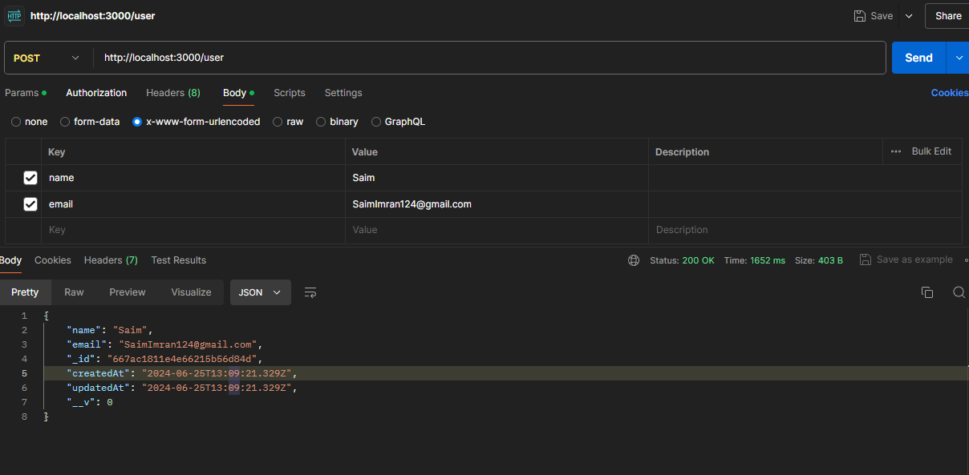

As I did I previously as well so I had some ore data as well   
GET REQUEST

No I am updating the third data name and email address by selecting the auto generated ID PUT Request:

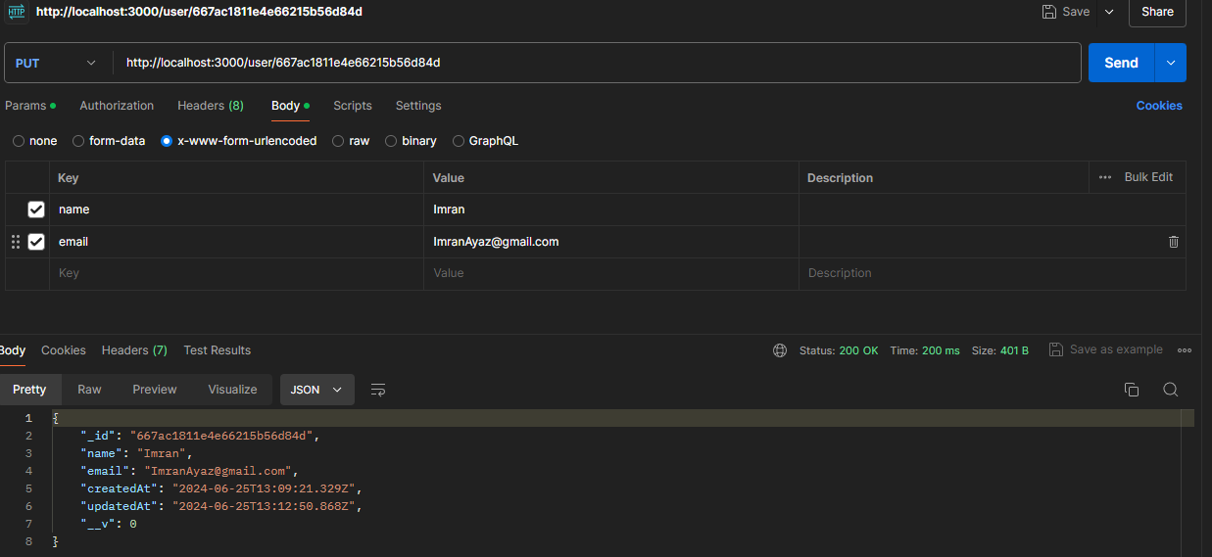

Now GET Request again: 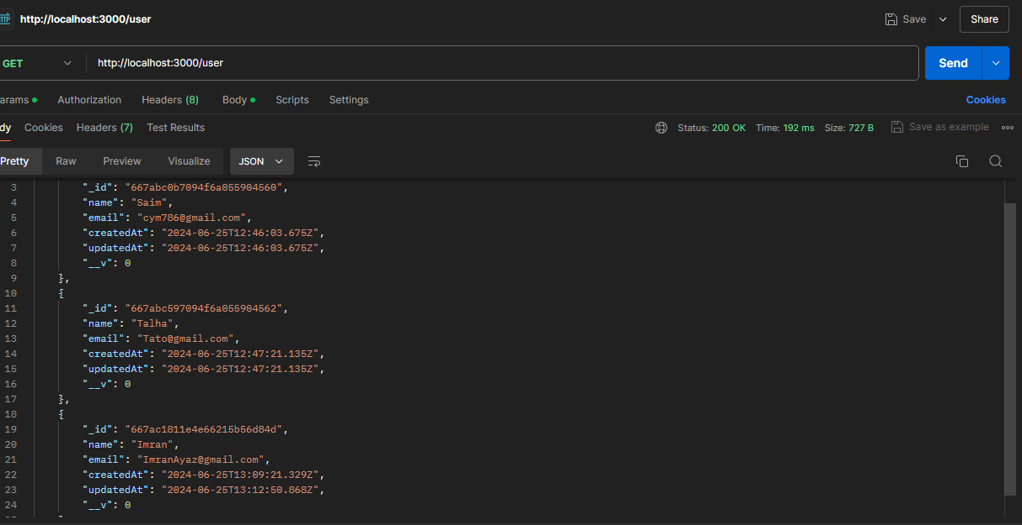  
look the third data changed

GET Request:

